1 Create a simple application in JSP which displays product list and price to user. User can select product and add them to cart. Cart will be managed using Session. Put a checkout button which can be used to view the final cart values. Also create a header section on all pages to display current date and time.

Product.html

<html>

<head>

<title>Online Store</title>

</head>

<body>

<pre>

<hr><h1>ONLINE STORE</h1><hr>

<form method="POST" action="index.jsp">

<table border=1>

<tr>

<td>Enter Name</td>

<td><input type="text" name="nm"></td>

</tr>

<tr>

<td>Product List</td>

<td>Choice</td>

<td>Price</td>

<td>Product Quantity</td>

</tr>

<tr>

<td>AC</td><td> <input type="checkbox" name="ac"value="Ac" ></td>

<td><input type="text" name="aprice" value="55000" ></td>

<td><input type="text" name="aqan"></td>

</tr>

<tr>

<td>Tv</td><td> <input type="checkbox" name="tv" value="tv" ></td>

<td><input type="text" name="tprice" value="36000" ></td>

<td><input type="text" name="tqan"></td>

</tr>

<tr>

<td>WashingMachine</td><td> <input type="checkbox" name="washingmachine" value="washingmachine" ></td>

<td><input type="text" name="wprice" value="75000" ></td>

<td><input type="text" name="wqan"></td>

</tr>

</table>

<input type="submit" name="submit" value="Buy Now">

</form>

</pre>

</body>

</html>

datetime.jsp

<%@ page language="java" contentType="text/html" %>

<% out.print("Today is:"+java.util.Calendar.getInstance().getTime()); %>

index.jsp

<%@ page language="java" contentType="text/html" %>

<jsp:include page="datetime.jsp" />

<%! static int total = 0;

int price1 = 0;

int price2 = 0;

int price3 = 0;

%>

<%

session.setAttribute("user",request.getParameter("nm"));

String p1 = request.getParameter("ac");

String p2 = request.getParameter("tv");

String p3 = request.getParameter("washingmachine");

int p1price = Integer.parseInt(request.getParameter("aprice"));

int p2price = Integer.parseInt(request.getParameter("tprice"));

int p3price = Integer.parseInt(request.getParameter("wprice"));

out.print("<h1>Your Selected items into Cart Mr." + request.getParameter("nm") + "</h1>");

if(p1 != null){

out.println("Product Name : " + p1 );

out.println("<br>");

out.println("Product Price : " + p1price );

out.println("<br>");

price1 = p1price *Integer.parseInt(request.getParameter("aqan"));

out.println("<br>");

}

if(p2 != null){

out.println("Product Name : " + p2);

out.println("<br>");

out.println("Product Price : " + p2price );

out.println("<br>");

price2 = p2price* Integer.parseInt(request.getParameter("tqan"));

out.println("<br>");

}

if(p3 != null){

out.println("Product Name : " + p3);

out.println("<br>");

out.println("Product Price : " + p3price );

out.println("<br>");

price3 = p3price*Integer.parseInt(request.getParameter("wqan"));

out.println("<br>");

}

total = price1 + price2 + price3;

session.setAttribute("price",total);

%>

<pre>

<form action="check.jsp" method="post">

<input type="submit" name="checkout" value="Check Out">

<a href="product.html">BACK</a>

</form>

</pre>

check.jsp

<%@ page language="java" contentType="text/html" %>

<%

String name = (String)session.getAttribute("user");

int p = (Integer) session.getAttribute("price");

out.println("<h1> Mr." + name + "</h1>");

out.println("<h1>Total Amount is " + p + "</h1>");

%>

O/P:-

1)product.html

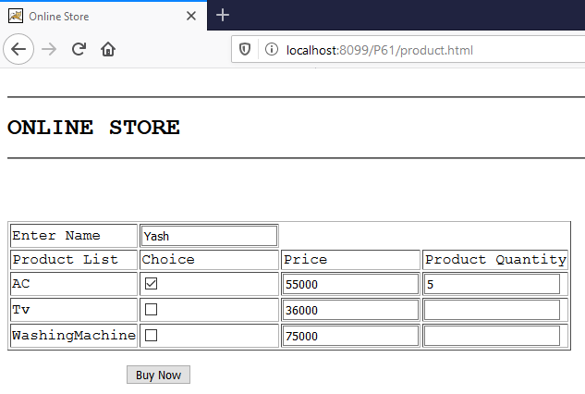

2) index.jsp

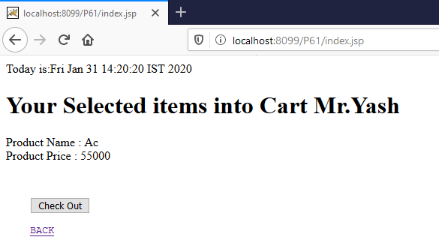

3) check.jsp

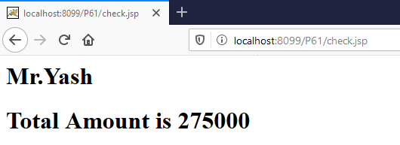

2 Create a html page which takes input from user like “a+b+c”. Write a simple bean class to take the input and process it to calculate necessary output.

Index.html:

<!DOCTYPE html>

<html>

<body>

<form action="details.jsp" method="post">

Expression:<input type="text" name="exp"><br><br>

<input type="submit" name="submit">

</form>

</body>

</html>

Details.jsp:

<jsp:useBean id="n" class="com.simple_bean" />

<jsp:setProperty property="exp" name="n"/>

${ n.getCal() }

Simple_bean.java:

package com;

importjavax.script.*;

public class simple_bean {

private String exp;

public void setExp(String exp){

this.exp = exp;

}

public String getExp()

{

return exp;

}

public double getCal() throws Exception

{

ScriptEngineManager manager = new ScriptEngineManager();

ScriptEngine engine = manager.getEngineByName("js");

Object result = engine.eval(exp);

returnDouble.parseDouble(result.toString());

}

}

Output:-

1)Login.html

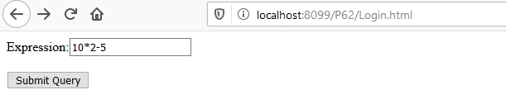

2)details.jsp

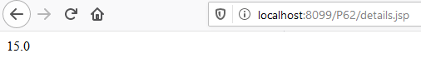

3 Create a simple login application using MVC architecture. Use JSP page, Servlet and Simple Bean for the same. Collect the valid user names and passwords from Context/Application scope. If valid login than display welcome page else provide a valid error page.

Index.jsp:

<!DOCTYPE html>

<html>

<body>

<form method="post" action="check">

Username:<input type="text" name="username"><br><br>

Password:<input

type="password" name="password"><br><br>

<input type="submit" name="submit">

</form>

</body>

</html>

Login.java

package com;

public class Login {

private String username,password;

public void setUsername(String username)

{

this.username = username;

}

public String getUsername(){

return username;

}

public void setPassword(String password)

{

this.password = password;

}

public String getPassword(){

return password;

}

Public boolean validate(String u, String p)

{

if(username.equals(u) && password.equals(p))

{

return true;

}

else

{

return false;

}

}

}

Controller.java

package com;

import javax.servlet.*;

import javax.servlet.http.*;

import java.io.*;

public class Controller extends HttpServlet {

public void doPost(HttpServletRequest req, HttpServletResponse res) throws ServletException,IOException {

String user = req.getParameter("username");

String pass = req.getParameter("password");

ServletContext context = getServletContext();

Login l = new Login();

l.setUsername(user);

l.setPassword(pass);

boolean validate;

validate=l.validate(context.getInitParameter("username"),context.getInitParameter("password"));

if(valid) {

HttpSession session = req.getSession(true);

session.setAttribute("user",user);

res.sendRedirect("login-success.jsp");

}

Else

{

res.sendRedirect("login-error.jsp");

}

}

}

Login-success.jsp:

<!DOCTYPE html>

<html>

<body>

Welcome ${ sessionScope.user }

</body>

</html>

Login-error.jsp:

<html>

<body>

Wrong username and password

</body>

</html>

Web.xml:

<web-app>

<context-param>

<param-name>username</param-name>

<param-value>admin</param-value>

</context-param>

<context-param>

<param-name>password</param-name>

<param-value>admin</param-value>

</context-param>

<servlet>

<servlet-name>Controller</servlet-name>

<servlet-class>com.Controller</servlet-class>

</servlet>

<servlet-mapping>

<servlet-name>Controller</servlet-name>

<url-pattern>/check</url-pattern>

</servlet-mapping>

</web-app>

O/P:-

1)Index.jsp

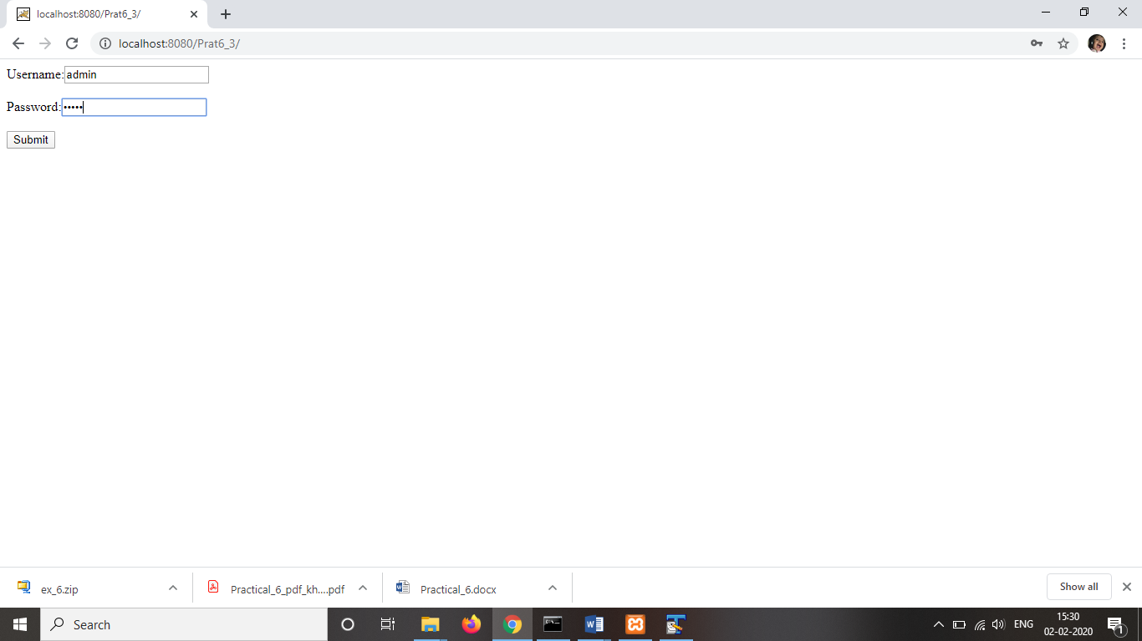

2)login-success.jsp

